**ANALYSIS OF DEMAND FOR MONEY**

**USING MULTIPLE LINEAR REGRESSION**

**ABSTRACT**

In monetary economics, the demand for money is the desired holding of financial assets in the form of money. that is, cash or bank deposits rather than investments. This project examines the determinants of demand for money and its stability in India, using annual time series data spanning from 1978 to 2018. Economic analysis of the money demand function is qualitatively identified by applying Multiple Linear Regression technique. This can be done by creating a Multilinear model in R. The need to find the demand is significant because the demand for real money balances serves as the core link between the monetary policy and the real sector of the economy. Based on the annual data under the period of study, cointegration results reveal that there is a long-run relationship between real money balances and the explanatory variables namely, real GDP, deposit interest rate, WPI, real exchange rate and inflation rate. Also, the total number of notes printed in the previous year must also be considered for multilinear model. Consistent with money demand theory, the results show that the demand for real money balances is positively related with scale variable (real GDP) but it responds inversely to opportunity cost of holding money (deposit interest rate and inflation rate). Moreover, results provide evidence that the demand for real money balances and real exchange rate are positively associated. Furthermore, after incorporating the stability tests, the empirical results show that real money demand function is stable over the 1978-2018period, suggesting that it is possible to use the narrow money aggregate as target of monetary policy in India.

# TABLE OF CONTENTS

|  |  |  |
| --- | --- | --- |
| **CHAPTER NO** | **TITLE** | **PAGE NO** |
|  | **ABSTRACT** | iii |
|  | **LIST OF FIGURES** | v |
|  | **LIST OF ABBREVIATIONS** | vi |
| **1** | **INTRODUCTION** | 1 |
|  | 1.1 FACTORS THAT INFLUENCE THE DEMAND FOR MONEY | 1 |
|  | 1.1.1 GDP | 2 |
|  | 1.1.2 Inflation Rate | 3 |
|  | 1.1.3 Interest Rate | 4 |
|  | 1.1.4 WPI | 4 |
| **2** | **LITERATURE SURVEY** | 6 |
| **3** | **SOFTWARE REQUIREMENTS** | 7 |
|  | 3.1 RStudio | 7 |
| **4** | **PROJECT DESCRIPTION** | 9 |
|  | 4.1 OBJECTIVE | 9 |
|  | 4.2 EXISTING SYSTEM | 9 |
|  | 4.2.1 Drawbacks | 10 |
|  | 4.3 PROPOSED METHODOLOGY | 10 |
|  | 4.3.1 Advantages | 11 |

|  |  |  |
| --- | --- | --- |
|  | 4.4 DESCRIPTION OF LEVELS IN ANALYSIS | 11 |
| **5** | **TECHNOLOGY DESCRIPTION** | 13 |
|  | 5.1 LANGUAGE USED | 13 |
|  | 5.1.1 R | 13 |
|  | 5.2 ALGORITHM USED | 14 |
|  | 5.2.1 Multiple Linear Regression | 14 |
| **6** | **IMPLEMENTATION** | 16 |
|  | 6.1 DATASET INFORMATION | 16 |
|  | 6.2 STEPS IN PREDICTION ANALYSIS | 16 |
|  | 6.3 DATASET PREPROCESSING | 17 |
|  | 6.4 PROCESSING THE DATA | 17 |
|  | 6.4.1 Reading the File | 17 |
|  | 6.4.2 Identification of Input and Output Variables | 18 |
|  | 6.4.3 Scatter Plot | 19 |
|  | 6.4.4 Construction of Multilinear Model Using R | 19 |
|  | 6.4.5 Output | 19 |
|  | 6.4.6 Result | 21 |
| **7** | **CONCLUSION** | 22 |
| **8** | **REFERENCE** | 23 |

**LIST OF FIGURES**

|  |  |  |
| --- | --- | --- |
| **FIGURE NO** | **TITLE** | **PAGE NO** |
| 1.1 | Graph of GDP Rate in India | 2 |
| 1.2 | Graph of Inflation Rate in India | 3 |
| 1.3 | Graph of Interest Rate in India | 4 |
| 1.4 | Graph of WPI Rate in India | 5 |
| 4.1 | Flow Chart describing the project | 12 |
| 6.1 | Dataset Used in the Project | 18 |
| 6.2 | Scatter plot of the Dataset | 19 |

**LIST OF ABBREVIATIONS**

|  |  |
| --- | --- |
| **ABBREVIATION** | **EXPANSION** |
| CRAN | Comprehensive R Archive Network |
| GDP | Gross Domestic Product |
| VCEM | Virtual Connect Enterprise Manager |
| WPI | Wholesale Price Index |

**CHAPTER 1 INTRODUCTION**

Studies on the demand for money and its stability remain in the domain of rigorous investigation because demand for money plays a major role in macroeconomic analysis, especially in selecting appropriate monetary policy actions. Markedly, the relationship between the demand for money and its main determinants is an important building block in macroeconomic theories and is a crucial component in the conduct of monetary policy. Thus, understanding the robust determinants of demand for money and its stability can inform the setting of monetary policy. Conventionally, a good understanding of the stability and robust determinants of the demand for real money balances forms the core in the conduct of monetary policy as it enables a policy-driven change in monetary aggregates to have predictable influences on output, interest rate, and ultimately price through transmission mechanism. The central argument here is that the relationship between real money balances and the scale variable that measures the level of economic activity and opportunity cost variables plays an important role in macroeconomic analysis of a country.

## FACTORS THAT INFLUENCE THE DEMAND FOR MONEY

* + - GDP
    - Inflation rate
    - Interest rate
    - WPI

## GDP

* + - * GDP at purchaser's prices is the sum of gross value added by all resident producers in the economy plus any product taxes and minus any subsidies not included in the value of the products.
      * It is calculated without making deductions for depreciation of fabricated assets or for depletion and degradation of natural resources.
      * Data are in current U.S. dollars. Dollar figures for GDP are converted from domestic currencies using single year official exchange rates.
      * In 2018, GDP for India was 2,718.73 billion US dollars.

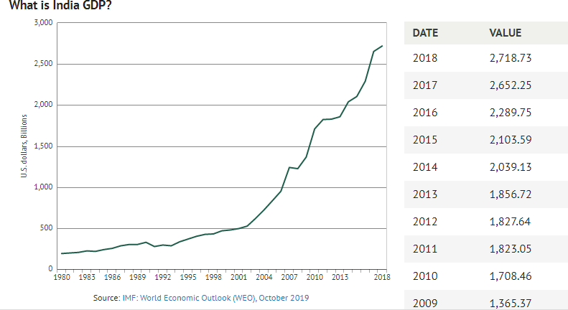

## Figure 1.1 Graph of GDP Rate in India

The Figure 1.1 describes the graph of GDP rate in India.

## Inflation Rate

* + - * Inflation as measured by the consumer price index reflects the annual percentage change in the cost to the average consumer of acquiring a basket of goods and services that may be fixed or changed at specified intervals, such as yearly.
      * Data for inflation are averages for the year, not end-of-period data. In 2018, the inflation rate for India was 3.4 %.
      * Though India's inflation rate fluctuated substantially in recent years, it tended to increase through 1999 - 2018 period ending at 3.4 % in 2018.

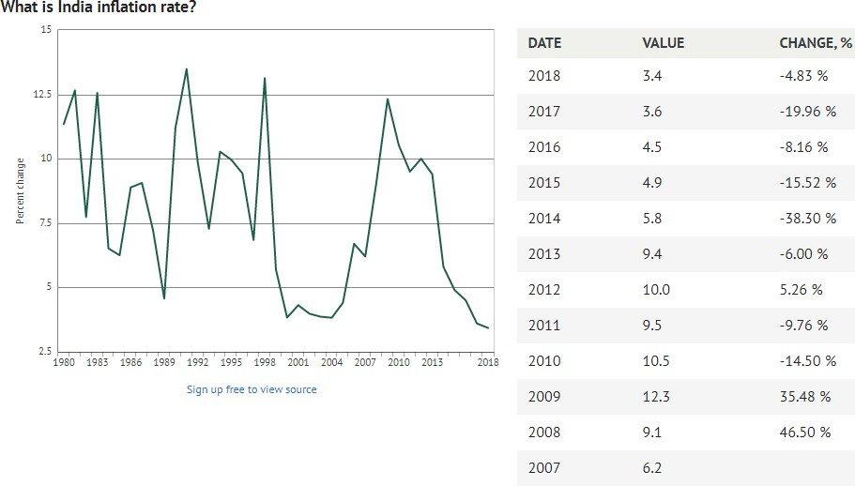

## Figure 1.2 Graph of Inflation Rate in India

The Figure 1.2 describes the graph of Inflation rate in India.

## Interest Rate

* + - * Real interest rate is the lending interest rate adjusted for inflation as measured by the GDP deflator.
      * In 2018, the real interest rate for India was 5.13 %. Though India's real interest rate fluctuated substantially in recent years, it tended to decrease through the 1999 - 2018 period ending at 5.13 % in 2018.

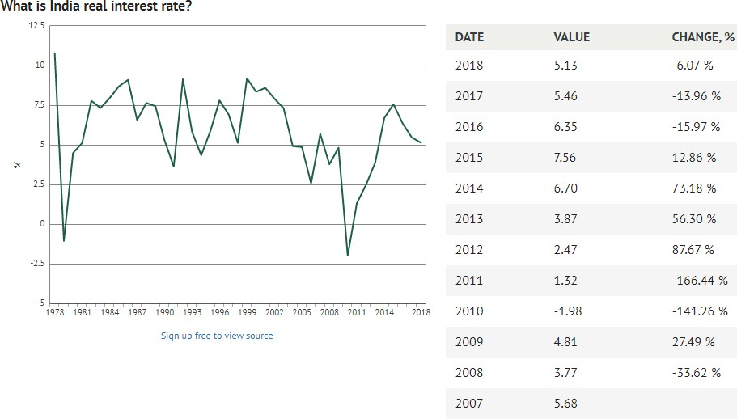

## Figure 1.3 Graph of Interest Rate in India

The Figure 1.3 describes the graph of Interest rate in India.

## WPI

* + - * Wholesale price index refers to a mix of agricultural and industrial goods at various stages of production and distribution, including import duties.
      * In 2018, the wholesale price index for India was 133.6 index.
      * Between 1969 and 2018, the wholesale price index of India grew substantially from 5.3 to 133.6 index rising at an increasing annual rate that reached a maximum of 28.57% in 1974 and then decreased to 4.27% in 2018.

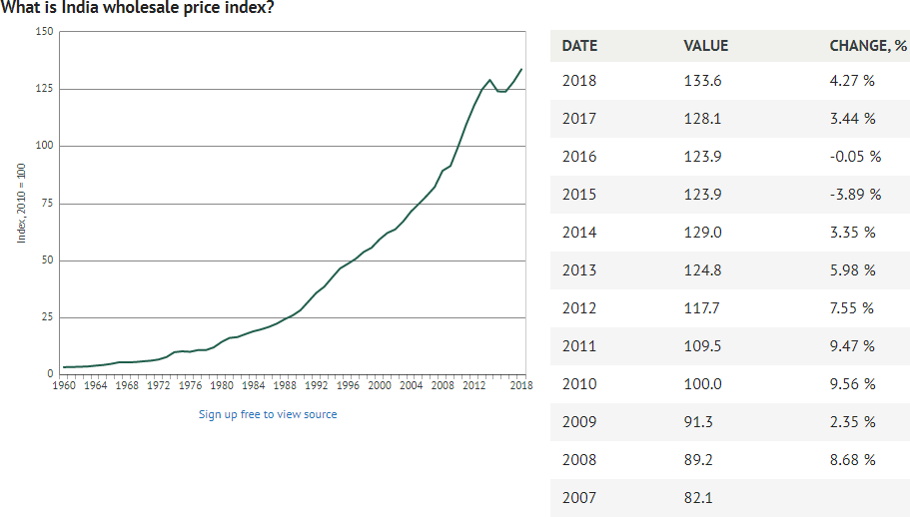

## Figure 1.4 Graph of WPI Rate in India

The Figure 1.4 describes the graph of WPI rate in India.

This chapter gives the introduction about the project. The next chapter will give information about Literature Survey of the project.

# CHAPTER 2 LITERATURE SURVEY

The Literature survey for this project is a research paper which examines the determinants of demand for money and its stability in Tanzania [4].

The study is thought to be significant because the demand for real money balances serves as the core link between the monetary policy and the real sector of the economy.

Based on the annual data under the period of study, cointegration results reveal that there is a long-run relationship between real money balances and the explanatory variables namely, real GDP, deposit interest rate, real exchange rate and inflation rate

The demand for real money balances is positively related with scale variables (real GDP) but it responds inversely to opportunity cost of holding money (deposit interest rate and inflation rate).

# CHAPTER 3 SOFTWARE REQUIREMENTS

This chapter discusses the Software and Tools that are required for the implementation of the project phase and the detailed specification.

## RSTUDIO

* + - R Studio is an integrated development environment (IDE) for R, a programming language for statistical computing and graphics.
    - It is available in two formats: RStudio Desktop is a regular desktop application while RStudio Server runs on a remote server and allows accessing RStudio using a web browser.
    - It includes a console, syntax-highlighting editor that supports direct code execution, as well as tools for plotting, history, debugging and workspace management.
    - The RStudio program can be run on the desktop or through a web browser.
    - The desktop version is available for Windows, Mac OS X, and Linux platforms and behaves similarly across all platforms, with minor differences for keyboard shortcuts.
    - RStudio provides many convenient and easy-to-use administrative tools for managing packages, the workspace, files, and more.
    - The project feature makes it easy to organize different workflows.
    - The source-code editor is easy to use, feature-rich, has excellent code-navigation features, and is well-integrated into the built-in console.
    - The console and source-code editor are tightly linked to R’s internal help system through tab completion and the help page viewer component.

This chapter explained the details of software and tools used in the project. The next chapter will give information about the project description.

# CHAPTER 4 PROJECT DESCRIPTION

This chapter discusses the description of the project which includes the problem definition, the existing system and the proposed methodology.

## PROBLEM DEFINITION

The Reserve Bank of India (RBI) prints money each year. For each year they need an estimate of how much money to be printed. The decision is based on various economic indicators like GDP, WPI, Interest rate etc. To provide a solution for this problem using Multiple linear regression.

## EXISTING SYSTEM

* + - Reserve bank of India currently prints money based on the growth rate of the economy, annual cash requirement of the country and by considering the number of notes currently in circulation.
    - RBI can print any amount of money with zero restrictions. The only problem is that RBI must manage the inflation rate and the sudden occurrence of the demonetisation crisis in the country.
    - In India, the printing of new notes is the sole right of the RBI.
    - RBI prints currency notes of all denominations except one rupee note.
    - All the one rupee notes are printed under the supervision of the Ministry of Finance and signed by the finance secretary, not by the governor of the RBI.

## Drawbacks

* + - * The current system requires much effort from the experts and RBI to print money every year.
      * This system does not support effectively during inflation and deflation crises.
      * This system Requires more time and manpower.
      * This system does not provide accuracy in results.

## PROPOSED METHODOLOGY

* + - Based on the annual data under the period of study, cointegration results reveal that there is a long-run relationship between real money balances and the explanatory variables namely, real GDP, deposit interest rate, real exchange rate and inflation rate.
    - The demand for real money balances is positively related with scale variables (real GDP) but it responds inversely to opportunity cost of holding money (deposit interest rate and inflation rate).
    - This system estimates the total money to be printed for the country using GDP and Interest rate values. The estimation formula gives an accurate solution even when an inflation or demonetisation occurs in the country.
    1. **Advantages**
       - This project reduces the effort needed for RBI to print money for every year.
       - This project works effectively even in an inflation deflation crisis.

## DESCRIPTION OF LEVELS IN ANALYSIS FIRST LEVEL

The First level describes collecting and analysing the required data for the analysis.

## SECOND LEVEL

The Second level involves the identification of input and output variables for the analysis. As it is multiple linear regression, the input variables must be more than two variables.

## THIRD LEVEL

The Third level is about plotting the data for visualization and interpretation.

## FOURTH LEVEL

The Fourth level is about constructing a Multilinear model using R with the given data for further analysing the demand for money.

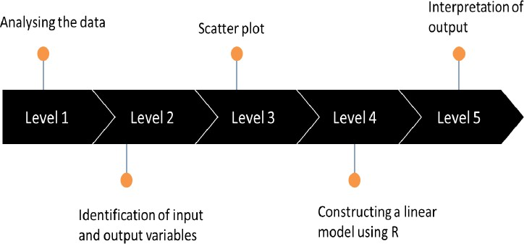

## FIFTH LEVEL

The Fifth level is the interpretation of the formula obtained from the multilinear model with this formula, the total money to be printed can be calculated if the GDP, Interest rate and WPI values are known.

## Figure 4.1 Flow Chart describing the project

The Figure 4.1 describes the flow diagram of the project

This chapter gives the detailed information about the description of the project. The next chapter will give information about the technology description of the project.

# CHAPTER 5 TECHNOLOGY DESCRIPTION

This chapter discusses the technology description of the project which includes language and algorithm used in the project.

## LANGUAGE USED

The language used in this project is R. The following lines explain the language R.

## R

* + - * R is a programming language and free software environment for statistical computing and graphics supported by the R Foundation for Statistical Computing.
      * The R language is widely used among statisticians and data miners for developing statistical software and data analysis.
      * R compiles and runs on Windows, Mac OS X, and numerous UNIX platforms (such as Linux). For most platforms, R is distributed in binary format for ease of installation.
      * Pre-compiled executables are provided for various operating systems. Although R has a command line interface, there are several third- party graphical user interfaces, such as RStudio, an integrated development environment.
      * R is much more than just its core language. As of 2011, there were more than 3,000 such packages hosted on CRAN and numerous more on other sites.
      * In total, R currently has functionality to address an enormous range of problems and still has room to grow.
      * R is designed around its core scripting language but also allows integration with compiled code written in C, C++, Fortran, Java, etc., for computationally intensive tasks or for leveraging tools provided for other languages.
      * The R software project was first started by Robert Gentleman and Ross Ihaka. The language was very much influenced by the S language, which was originally developed at Bell Laboratories by John Chambers and colleagues.
      * Since then, with the direction and talents of R’s core development team, R has evolved into the lingua franca for statistical computations in many disciplines of academia and various industries.

## ALGORITHM USED

The algorithm used in this project is Multi Linear Regression. The following lines explains about it.

## Multiple Linear Regression

Multiple regression is an extension of linear regression into relationships between more than two variables. In simple linear relation we have one predictor and one response variable, but in multiple regression we have more than one predictor variable and one response variable.

The general mathematical equation for multiple regression is:

## y = a + b1x1 + b2x2 +...bnxn.

Following is the description of the parameters used:

* **y** is the response variable.
* **a, b1, b2...bn** are the coefficients.
* **x1, x2, ...xn** are the predictor variables.

The multiple regression model is based on the following assumptions:

* There is a linear relationship between the dependent variables and the independent variables.
* The independent variables are not too highly correlated with each other.
* yi observations are selected independently and randomly from the population.
* Residuals should be normally distributed with a mean of 0 and variance σ.

When interpreting the results of a multiple regression, b coefficients are valid while holding all other variables constant ("all else equal"). The output from a multiple regression can be displayed horizontally as an equation, or vertically in table form.

This chapter gives the detailed information about the technology description of the project. The next chapter will give information about the implementation of the complete project.

# CHAPTER 6 IMPLEMENTATION

The implementation phase is where the project team works to produce the deliverables. The word “deliverable” means anything your project delivers. The deliverables for the project include all of the products and services that are performing for the client, customer and sponsor, including all the project management documents that are put together.

## DATASET INFORMATION

This dataset consists of GDP, WPI, Interest rate and notes issued for 1978-2018 period in India. These attributes are required for the prediction of the demand for money since multiple linear regression can be used only when there are multiple variables in an analysis. This dataset has been collected in real time from the sites such as,

* + - Knoema.com.
    - Kaggle.com
    - Dataworld.com

## STEPS IN PREDICTION ANALYSIS:

* + - Define your dataset.
    - Identification of input and output variables.
    - Know what you want to predict by plotting the variables.
    - Construct a linear model using R.
    - Apply your model to interpret the output.

## DATASET PREPROCESSING

Fill in missing values, smooth noisy data, identify or remove outliers, and resolve inconsistencies. Ignore the tuple - usually done when class label is missing. Use the attribute mean (or majority nominal value) to fill in the missing value. Use the attribute mean (or majority nominal value) for all samples belonging to the same class. Predict the missing value by using a learning algorithm: consider the attribute with the missing value as a dependent (class) variable and run a learning algorithm (usually Bayes or decision tree) to predict the missing value. Identify outliers and smooth out noisy data. Binning-Sort the attribute values and partition them into bins. Then smooth by bin means, bin median, or bin boundaries. Clustering- group values in clusters and then detect and remove outliers (automatic or manual). Regression- smooth by fitting the data into regression functions

## PROCESSING THE DATA

* + 1. **Reading The File**

money = read.csv("demandformoney .csv”) str(money)

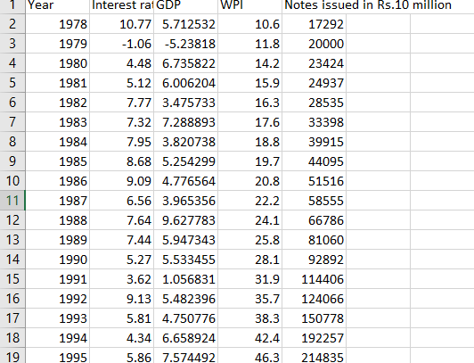

## Figure 6.1 Dataset Used in the Project

The Figure 6.1 describes the dataset used in the project.

* + 1. **Identification Of Output And Input Variables: Formula:** Money_printed = f ( GDP, Interest_RATE , WPI ) **Output variable**: Money_printed

**Input variables:** GDP, Interest_RATE , WPI

## Scatter Plot

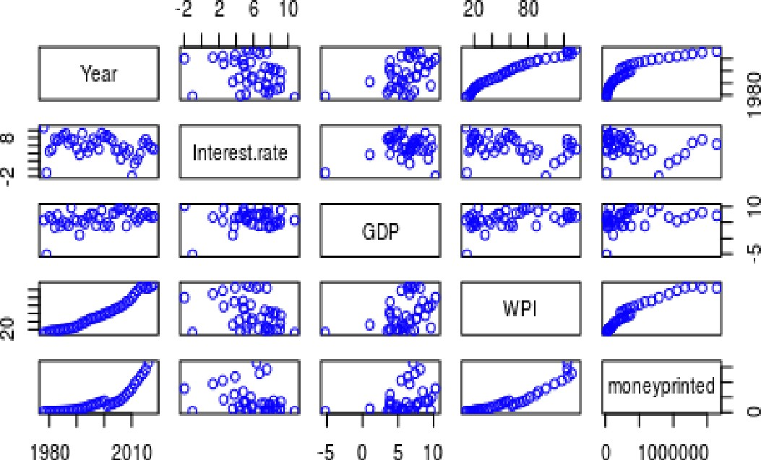

**Figure 6.2 Scatter plot of the Dataset**

The Figure 6.2 describes the Scatter plot of the dataset.

All the Input variables seem to be fairly, linearly correlated with our output variable Money printed except for WPI.

## Constructing A Multi Linear Model Using R

* multilinearmodel = lm (moneyprinted ~ GDP + Interest.rate + WPI, data = money)
* summary(multilinearmodel)

## Output

**Call:**

lm(formula = moneyprinted ~ GDP + Interest.rate + WPI, data = money)

## Residuals:

Min 1Q Median 3Q Max

-271713 -66042 3187 58287 493508

## Coefficients:

Estimate Std. Error t value Pr(>|t|)

|  |  |  |
| --- | --- | --- |
| (Intercept) | -258666.8 | 84289.4 -3.069 0.00413 ** |
| GDP | -13766.0 | 9874.3 -1.394 0.17207 |
| Interest.rate | 10707.5 | 9745.9 1.099 0.27941 |
| WPI | 11595.2 | 781.5 14.838 < 2e-16 *** |
| --- |  |  |

Signif. codes: 0 ‘***’ 0.001 ‘**’ 0.01 ‘*’ 0.05 ‘.’ 0.1 ‘ ’ 1 **Residual standard error:** 148800 on 35 degrees of freedom (2 observations deleted due to missingness)

Multiple R-squared: 0.8898, Adjusted R-squared: 0.8804

F-statistic: 94.23 on 3 and 35 DF, p-value: < 2.2e-16

## 6.4.5 Result

The final formula obtained after processing the dataset using Multi Linear Regression is

**MONEY PRINTED**= -258666.8+( -13766*GDP) +(10707.5*Interest rate) +(11595.2*WPI)

Now when the RBI needs to find how much Money is to be printed, they can plug in the values of GDP and Interest Rate into the equation above and find an estimate of money to be printed.

This chapter explained about the implementation of the project. The next chapter will conclude the project.

# CHAPTER 7 CONCLUSION

## 7.1 CONCLUSION

Investigation of the factors and stability of real money demand is very important because a good understanding of the stability and robust determinants of the demand for real money balances forms the core in the conduct of monetary policy as it enables a policy-driven change in monetary aggregates to have predictable influences on output, interest rate, and ultimately price. This project investigates the main factors that determine demand for real money balances in India. The project also examines the stability of the real money demand function over the 1978-2018 period. The VECM results show that scale variables and the currency substitution variable (real exchange rate) have a positive relationship with demand for real money balances. Moreover, consistent with the economic theory, empirical results suggest that opportunity cost variables have a negative effect on the demand for real money balances. The results of stability tests reveal that demand for real money balances in India is stable over the period of the study. These results suggest that it is possible to use the narrow money aggregate as the target of monetary policy in India. Equally important, monetary policy makers in the Bank of the India should consider real income, interest rate, inflation rates and real exchange rates as key policy factors.

# REFERENCES

1. <http://analyticspro.org/2016/03/02/r-tutorial-multiple-linear-regression/>
2. <https://knoema.com/atlas/India/topics/Economy/Financial-Sector->Interest

-rates/Real-interest-rate

1. <https://www.tutorialspoint.com/r/r_multiple_regression.htm>.

## Reference Paper Link:

[https://www.researc](http://www.researchgate.net/publication/318709995_An_Econometric_Analy)hg[ate.net/publication/](http://www.researchgate.net/publication/318709995_An_Econometric_Analy)318[709995_An_Econometric_Analy](http://www.researchgate.net/publication/318709995_An_Econometric_Analy) sis_of_Demand_for_Money_and_its_Stability_in_Tanzania.